ZR 4/6 Yo’ldoshev Davronbek

1-topshiriq 5.1-masala.

**Savol**

N ta sondan iborat massiv berilgan. Juft sonlarni o’sish tartibda va ularni sonini chiqaring.

**Dastur kodi**

**arr = [5,8,9,12,7,4]**

**arr_juft = []**

**k= 0**

**for i in arr:**

**if i%2==0:**

**arr_juft.append(i)**

**k+=1**

**print("Berilgan massiv: ",arr, " Natija: ",sorted(arr_juft), " juft sonlar: ", k)**

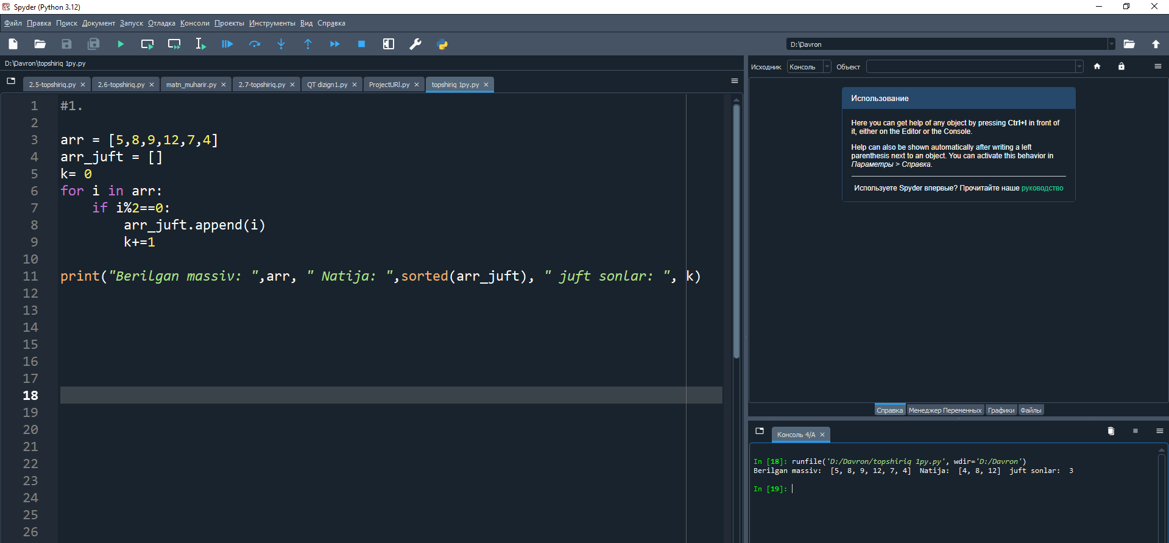

**5.2-masala**

**Savol**

N ta butun son berilgan Quyidagi ketma ketlikni hisoblang. S=1.1-1.2+1.3-1.4+…

Shart operatoridan foydalanmang.

**Dastur kodi**

n=int(input("n= "))

s1 = 1.1

s2 = -1.2

su1=0

su2 = 0

for i in range(n):

s1 += 0.2

su1 += s1

s2 += -0.2

su2 += s2

Su = su1 + su2

print(Su)

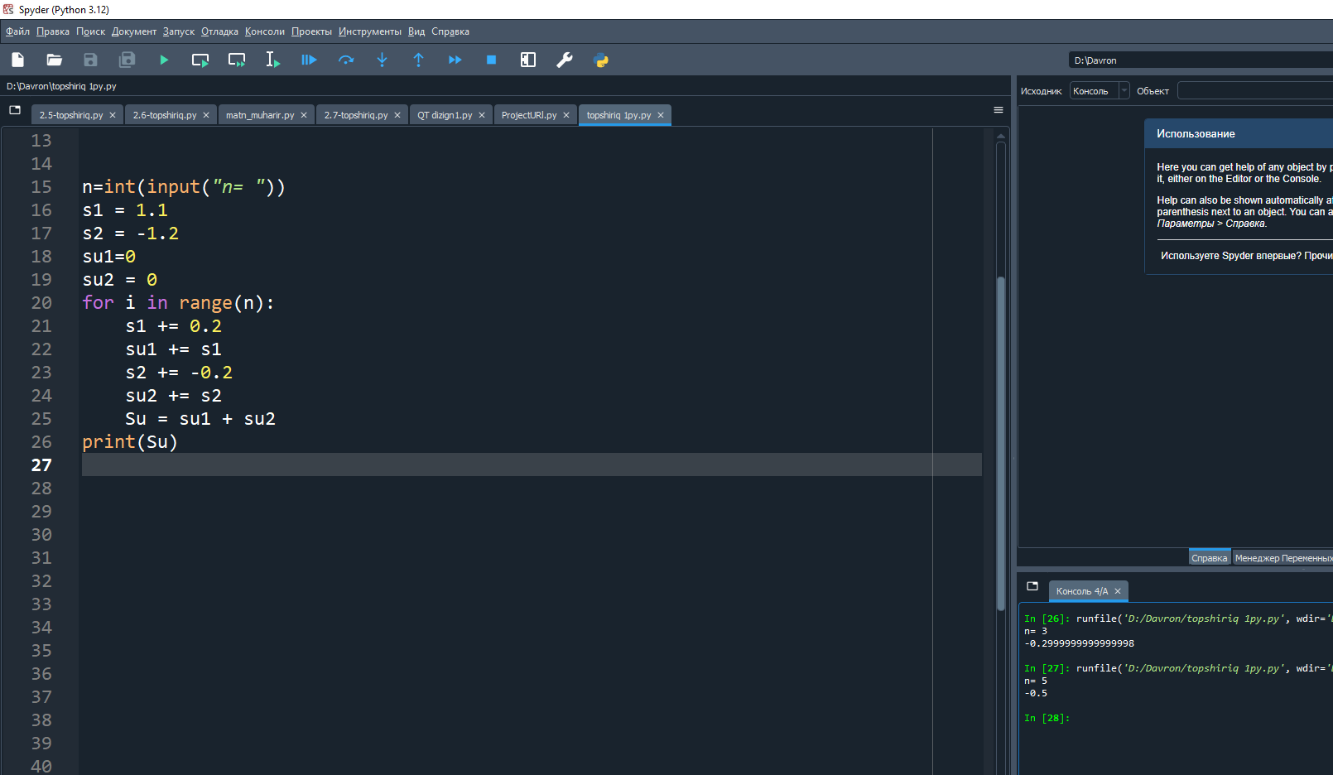

**5.3-masala**

**Savol**

Satr berilgan.Satrdagi hamma harflarni kichikka, kichigini kattasiga aylanitruvchi dastur tuzing.

**Dastur kodi**

text = input("matn kiriting: ")

satr = ""

for i in text:

if i.islower():

satr += i.upper()

else:satr += i.lower()

print(satr)

